Citi Bike June 2013: Explainable ML Results
Generated 2026-10-24 20:33. Unit of analysis: station-hour. Models: Linear Regression, Decision Tree, Random Forest and XGBoost.

Tables
Table 4.1 Data-cleaning log
Cleaning step | Records
Raw trip records loaded | 577703
Unparseable start timestamp removed | 0
Exact duplicate records removed | 0
Missing start-station id removed | 0
Implausible coordinates removed | 0
Implausible trip duration (flagged only) | 344
Records retained for aggregation | 577703

Table 4.2 Missingness in the retained raw fields
Variable | Missing_n | Missing_pct
started_at | 0 | 0.0000
ended_at | 0 | 0.0000
start_station_id | 0 | 0.0000
start_station_name | 0 | 0.0000
start_lat | 0 | 0.0000
start_lng | 0 | 0.0000
member_casual | 0 | 0.0000
tripduration | 0 | 0.0000
bike_id | 0 | 0.0000

Table 4.3 Descriptive statistics of station-hour demand
Statistic | Hourly demand (rides)
count | 240814.0000
mean | 2.3980
std | 3.8000
min | 0.0000
25% | 0.0000
50% | 1.0000
75% | 3.0000
90% | 7.0000
95% | 10.0000
99% | 18.0000
max | 61.0000

Table 4.4 Data dictionary of engineered predictors
Feature | Group | Definition
lag_1 | Lagged demand | Demand in the previous hour at the same station
lag_24 | Lagged demand | Demand 24 hours earlier at the same station
lag_168 | Lagged demand | Demand 168 hours (one week) earlier at the same station
roll_3 | Lagged demand | Mean demand over the previous 3 hours (shifted)
roll_24 | Lagged demand | Mean demand over the previous 24 hours (shifted)
hour | Calendar | Hour of day (0-23)
dow | Calendar | Day of week (0 = Monday)
is_weekend | Calendar (binary) | 1 if Saturday or Sunday
hour_sin | Cyclical | Sine encoding of hour
hour_cos | Cyclical | Cosine encoding of hour
dow_sin | Cyclical | Sine encoding of day of week
dow_cos | Cyclical | Cosine encoding of day of week
am_peak | Calendar (binary) | 1 if hour is 07:00-09:59
pm_peak | Calendar (binary) | 1 if hour is 16:00-19:59
station_code | Spatial | Ordinal station identifier
lat | Spatial | Station latitude
lng | Spatial | Station longitude
station_hist_mean | Spatial | Mean demand of the station in the training period only

Table 4.5 Chronological data partitions
Partition | Start | End | Station-hours | Share (%) | Mean demand
Training | 2013-06-08 00:00:00 | 2013-06-24 03:00:00 | 129592 | 70.2000 | 2.4100
Validation | 2013-06-24 04:00:00 | 2013-06-27 14:00:00 | 27722 | 15.0000 | 3.3690
Test | 2013-06-27 15:00:00 | 2013-07-01 00:00:00 | 27388 | 14.8000 | 3.4510

Table 4.6 Hyperparameter search spaces and selected configurations
Model | Search space | Selected configuration | CV MAE
Linear Regression | none (standardised features) | intercept + standardisation | -
Decision Tree | max_depth {6,10,14} x min_samples_leaf {20,50} | {'max_depth': 10, 'min_samples_leaf': 50} | 1.5526
Random Forest | max_depth {12,18}, min_samples_leaf 5, max_features 0.6 (200 trees) | {'n_estimators': 200, 'min_samples_leaf': 5, 'max_features': 0.6, 'max_depth': 12} | 1.4670
XGBoost | learning_rate {0.05,0.1} x max_depth {6,8}, 400 trees, subsample/colsample 0.8 | {'n_estimators': 400, 'subsample': 0.8, 'colsample_bytree': 0.8, 'learning_rate': 0.05, 'max_depth': 6} | 1.4997

Table 4.7 Validation-set performance
Model | MAE | RMSE | R²
Linear Regression | 1.7821 | 2.9252 | 0.5819
Decision Tree | 1.7841 | 2.9500 | 0.5748
Random Forest | 1.6613 | 2.7308 | 0.6356
XGBoost | 1.6452 | 2.7020 | 0.6433

Table 4.8 Test-set performance
Model | MAE | RMSE | R² | Training time (s)
Linear Regression | 1.8562 | 2.8154 | 0.6131 | 0.1000
Decision Tree | 1.8249 | 2.8572 | 0.6015 | 0.8000
Random Forest | 1.7142 | 2.6537 | 0.6562 | 76.7000
XGBoost | 1.7111 | 2.6754 | 0.6506 | 4.4000

Table 4.9 Naive seasonal benchmark
Model | MAE | RMSE | R²
Naive (demand 24h earlier) | 2.4017 | 3.9380 | 0.2430

Table 4.10 Test MAE by temporal segment
Segment | n | Linear Reg. | Dec. Tree | Random Forest | XGBoost
Weekday | 11356 | 1.8910 | 1.8680 | 1.7470 | 1.7540
Weekend | 16032 | 1.8320 | 1.7940 | 1.6910 | 1.6810
Morning peak (07-09) | 3006 | 1.6840 | 1.6800 | 1.4920 | 1.4480
Evening peak (16-19) | 5344 | 2.8470 | 2.9040 | 2.7050 | 2.7460
Off-peak | 19038 | 1.6050 | 1.5450 | 1.4710 | 1.4620
Night (00-05) | 6346 | 0.7590 | 0.6570 | 0.6340 | 0.6400

Table 4.11 Test MAE by observed demand band
Segment | n | Linear Reg. | Dec. Tree | Random Forest | XGBoost
0 rides | 8581 | 1.0260 | 0.8340 | 0.8210 | 0.8190
1-2 | 7144 | 1.5020 | 1.3320 | 1.2910 | 1.2560
3-5 | 5483 | 1.9160 | 1.9850 | 1.8860 | 1.8760
6-10 | 4064 | 2.4700 | 2.7560 | 2.4410 | 2.5000
>10 | 2116 | 5.0860 | 5.3030 | 4.9210 | 4.9240

Table 4.12 Standardised Linear Regression coefficients
Feature | Standardised coefficient
lag_1 | 1.2267
roll_3 | 0.6688
lag_168 | 0.6407
lag_24 | 0.4672
hour_cos | -0.4220
station_hist_mean | 0.2924
pm_peak | 0.1899
dow_cos | -0.1757
am_peak | 0.1687
hour_sin | -0.1415
is_weekend | 0.0867
hour | -0.0861
dow_sin | -0.0570
roll_24 | 0.0495
dow | -0.0233
station_code | -0.0043
lat | 0.0012
lng | -0.0009

Table 4.13 Permutation importance
Feature | Linear Regression | Decision Tree | Random Forest | XGBoost
lag_1 | 0.4545 | 0.5971 | 0.3278 | 0.2708
roll_3 | 0.1668 | 0.1051 | 0.1788 | 0.2577
hour_cos | 0.0880 | 0.2145 | 0.1912 | 0.2082
lag_24 | 0.1222 | 0.0655 | 0.0484 | 0.1136
roll_24 | -0.0016 | 0.0848 | 0.0628 | 0.1050
lag_168 | 0.2923 | 0.0458 | 0.0702 | 0.0921
station_hist_mean | 0.0204 | 0.0621 | 0.0588 | 0.0897
hour | 0.0038 | 0.1222 | 0.0723 | 0.0876
hour_sin | 0.0138 | 0.0214 | 0.0310 | 0.0589
dow | -0.0003 | 0.0139 | 0.0093 | 0.0283
dow_cos | 0.0148 | 0.0104 | 0.0057 | 0.0105
lat | -0.0000 | -0.0012 | 0.0042 | 0.0101
am_peak | 0.0047 | 0.0000 | 0.0017 | 0.0060
lng | -0.0000 | 0.0022 | 0.0014 | 0.0055
dow_sin | 0.0013 | 0.0152 | 0.0115 | 0.0054

Table 4.14 Mean absolute SHAP values
Feature | Mean |SHAP| Random Forest | Mean |SHAP| XGBoost
lag_1 | 1.1307 | 1.0347
roll_3 | 0.7294 | 0.7593
hour_cos | 0.5456 | 0.5885
lag_168 | 0.4643 | 0.3296
roll_24 | 0.2472 | 0.3195
station_hist_mean | 0.2516 | 0.3051
lag_24 | 0.2916 | 0.2423
hour | 0.2147 | 0.2111
hour_sin | 0.0787 | 0.1625
dow | 0.0693 | 0.1570
dow_sin | 0.0522 | 0.0661
dow_cos | 0.0359 | 0.0631
lng | 0.0256 | 0.0464
lat | 0.0188 | 0.0445
pm_peak | 0.0226 | 0.0419

Table 4.15 Feature ranking agreement
Comparison | n | Spearman ρ | Top 5 overlap | Jaccard
SHAP: Random Forest vs XGBoost | 15 | 0.9820 | 4/5 | 0.6670
Permutation: Random Forest vs XGBoost | 15 | 0.8820 | 3/5 | 0.4290
Random Forest: SHAP vs permutation | 14 | 0.9250 | 4/5 | 0.6670
XGBoost: SHAP vs permutation | 14 | 0.9380 | 4/5 | 0.6670

Table 4.17 Multi-criteria comparison
Criterion | Linear Regression | Decision Tree | Random Forest | XGBoost
Test MAE | 1.8562 | 1.8249 | 1.7142 | 1.7111
Test RMSE | 2.8154 | 2.8572 | 2.6537 | 2.6754
Test R² | 0.6131 | 0.6015 | 0.6562 | 0.6506
Training time (s) | 0.1000 | 0.8000 | 76.7000 | 4.4000
Intrinsic interpretability (described, not measured) | High (signed coefficients) | Moderate (upper rules readable; full depth-10 tree, only three levels shown) | Low (ensemble average) | Low (sequential ensemble)
Explanation tooling | Coefficients | Tree diagram, permutation | Permutation, TreeSHAP | Permutation, TreeSHAP
Tuning burden | Very low (no hyperparameters tuned) | Low | Moderate | High
Recommended use | Transparent benchmark / audit | Illustration only; caveat: weakest model in every busy demand band | Robust routine forecasting | Operational rebalancing where accuracy dominates

Figures
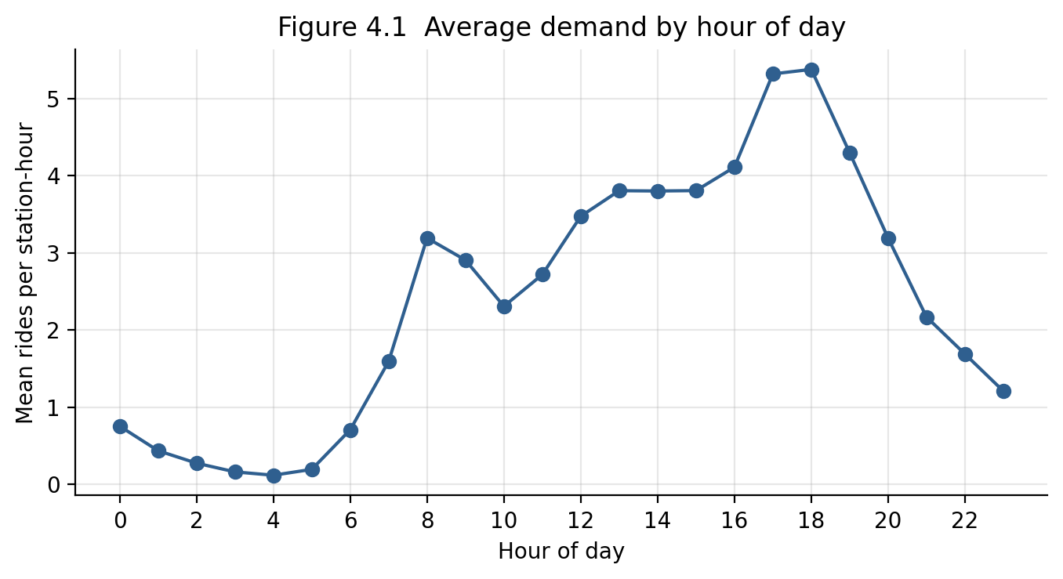
Figure 4.1
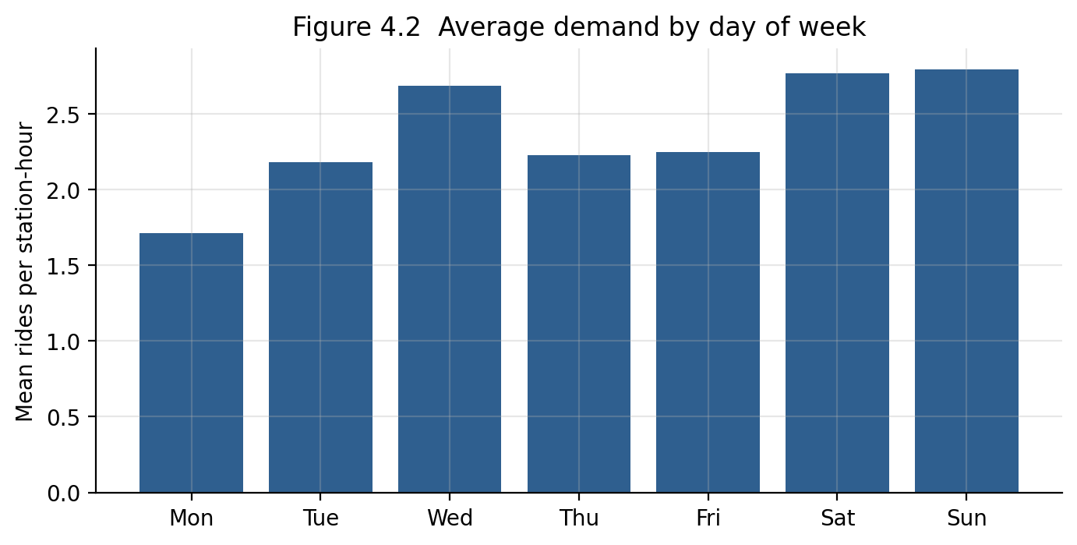
Figure 4.2
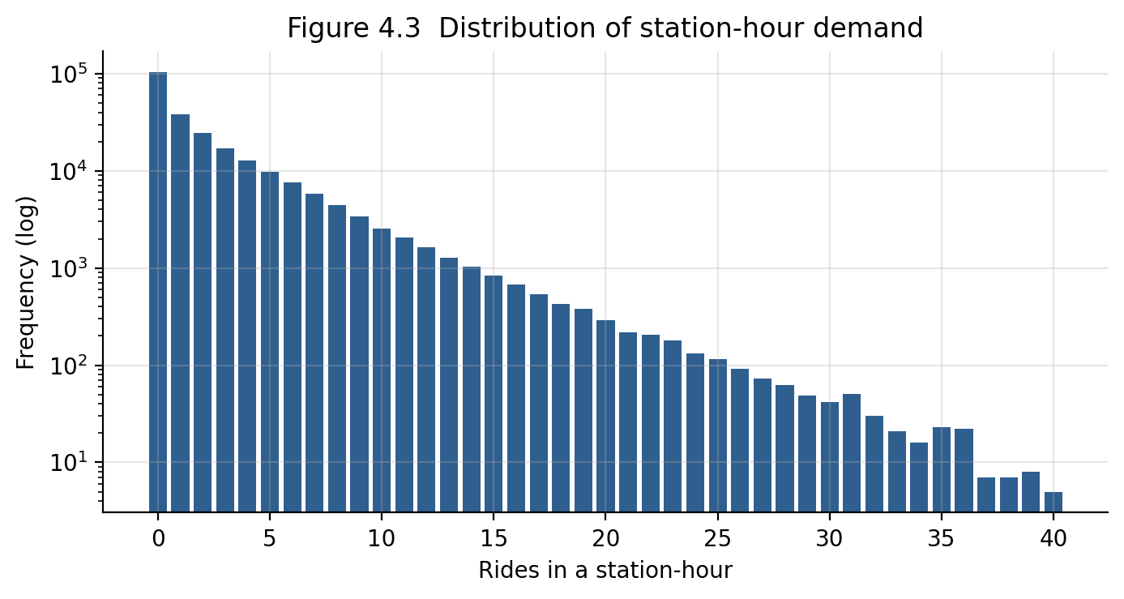
Figure 4.3
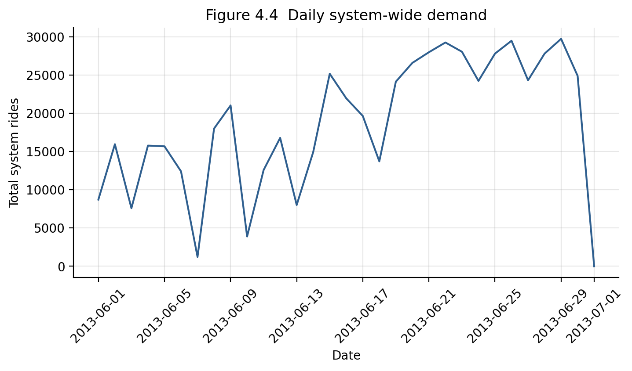
Figure 4.4
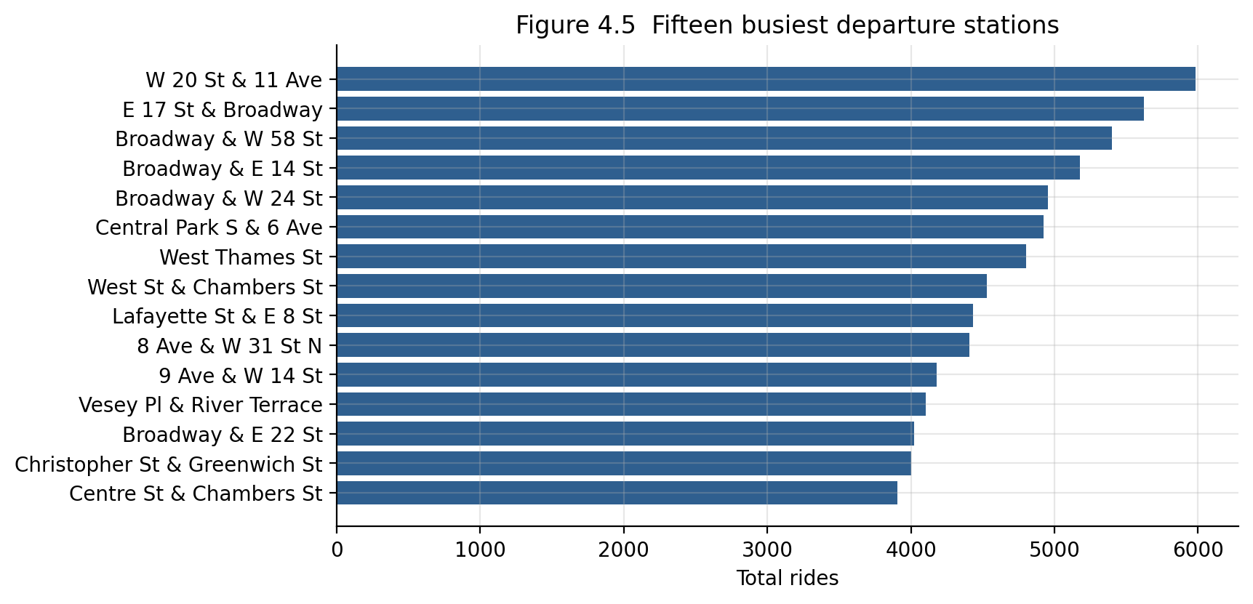
Figure 4.5
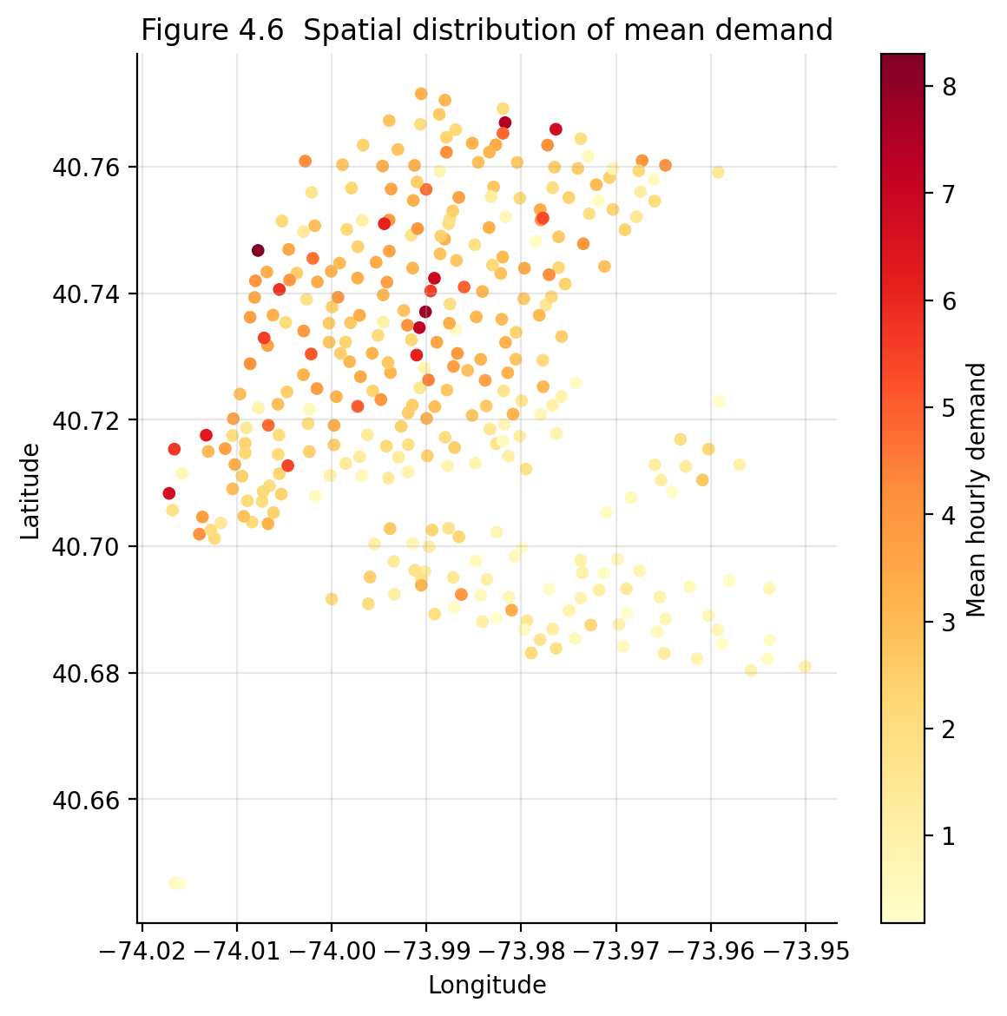
Figure 4.6
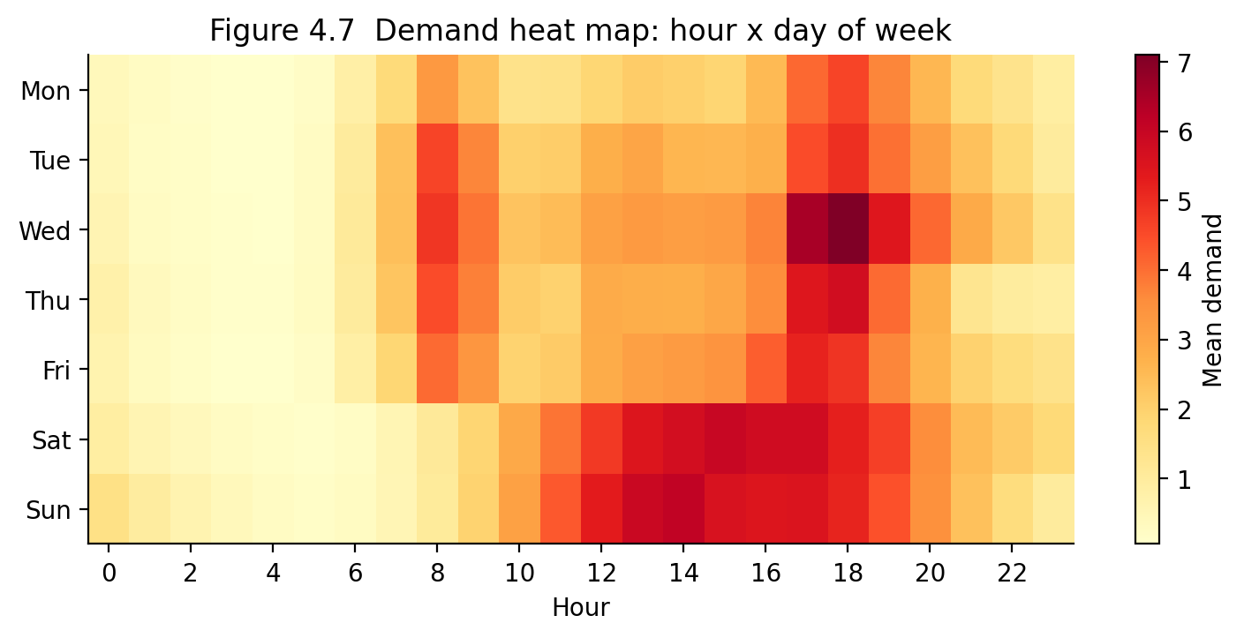
Figure 4.7
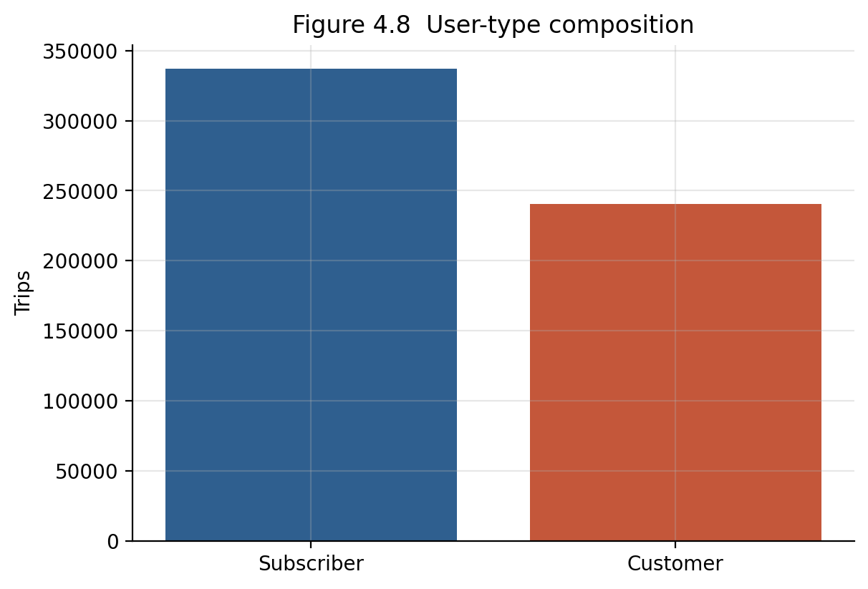
Figure 4.8
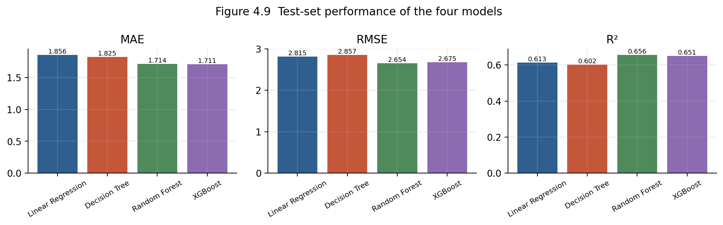
Figure 4.9
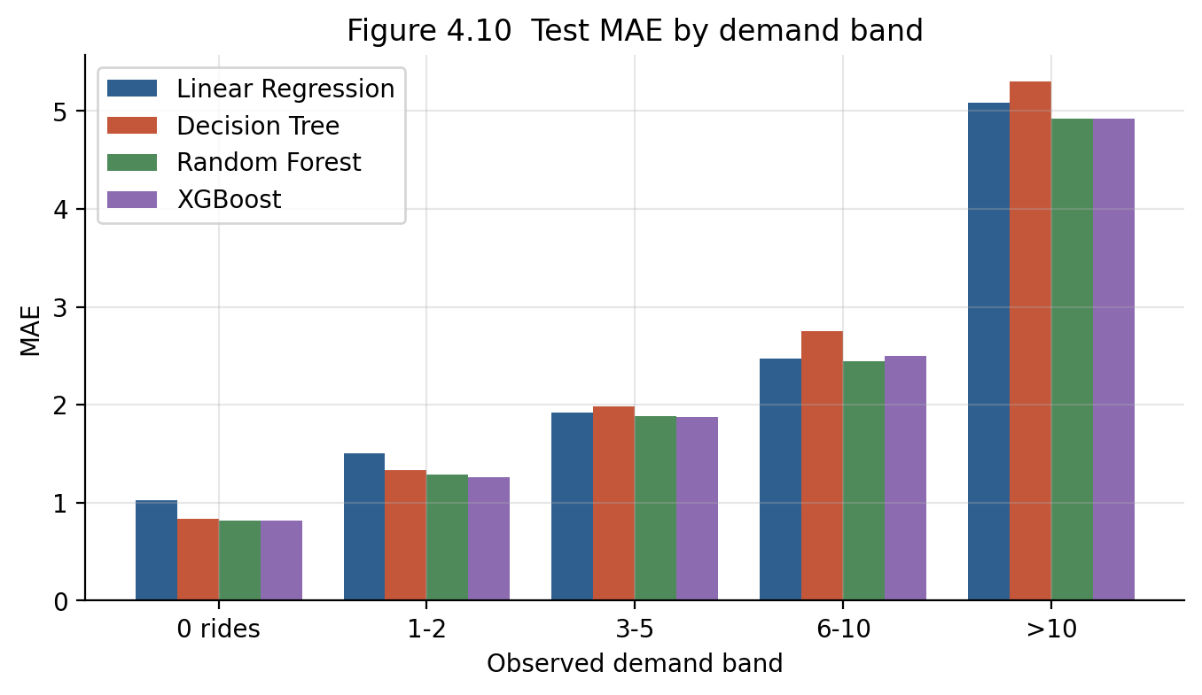
Figure 4.10
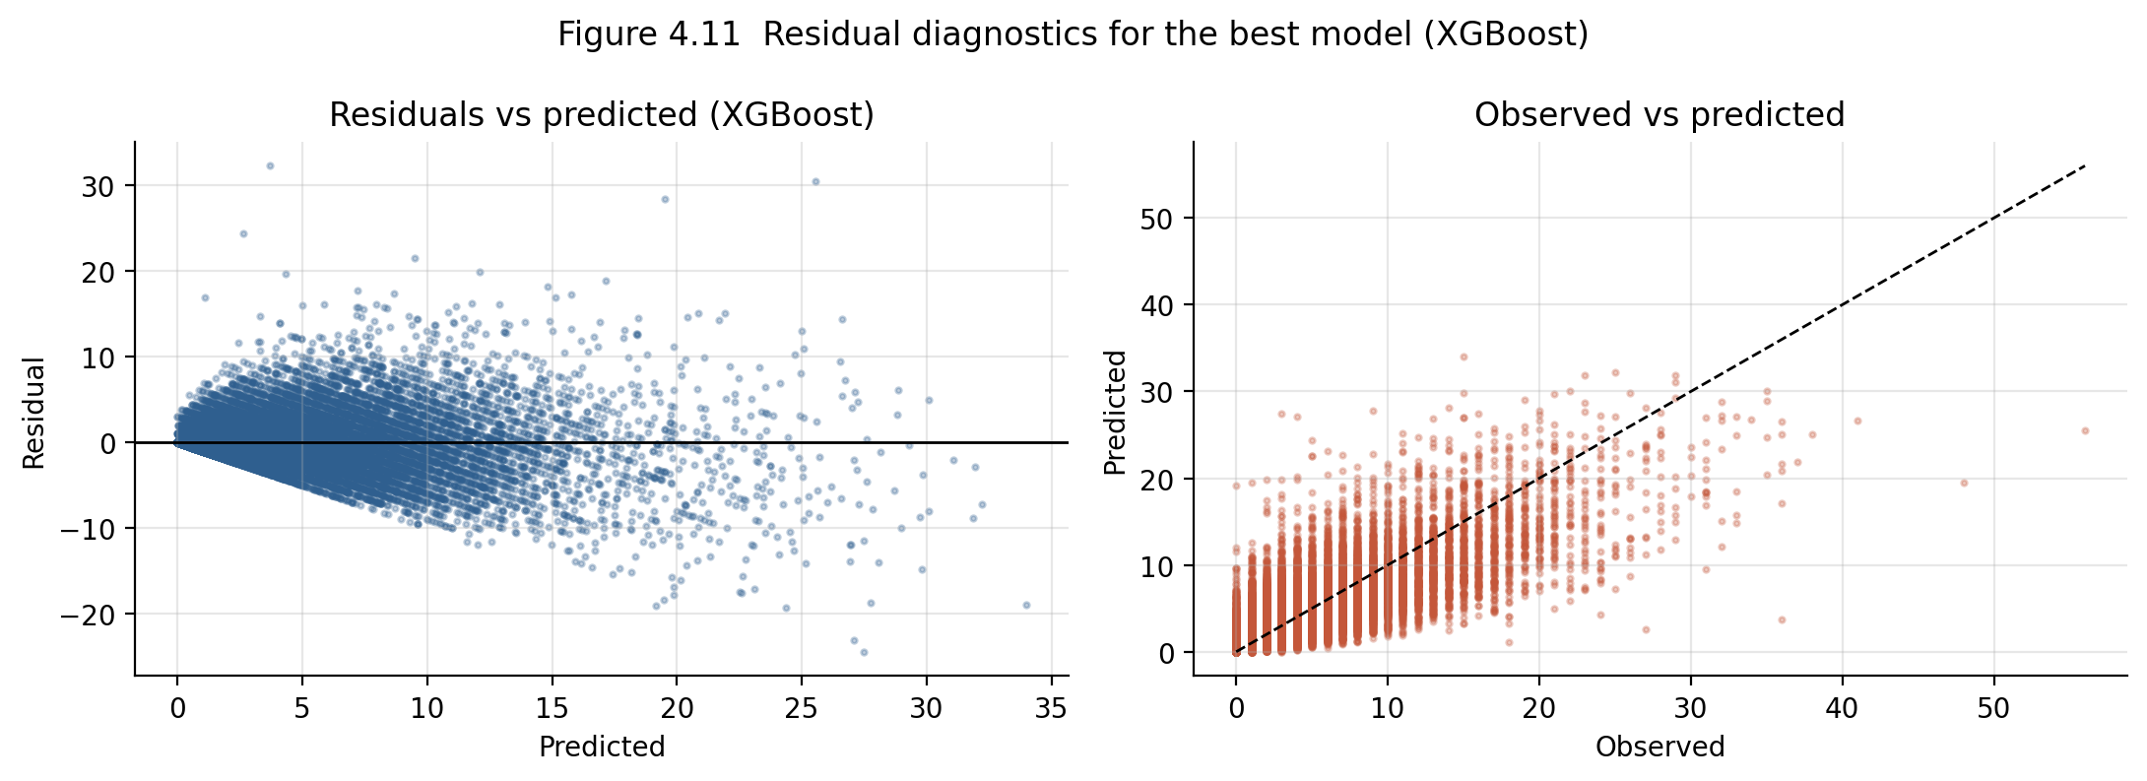
Figure 4.11
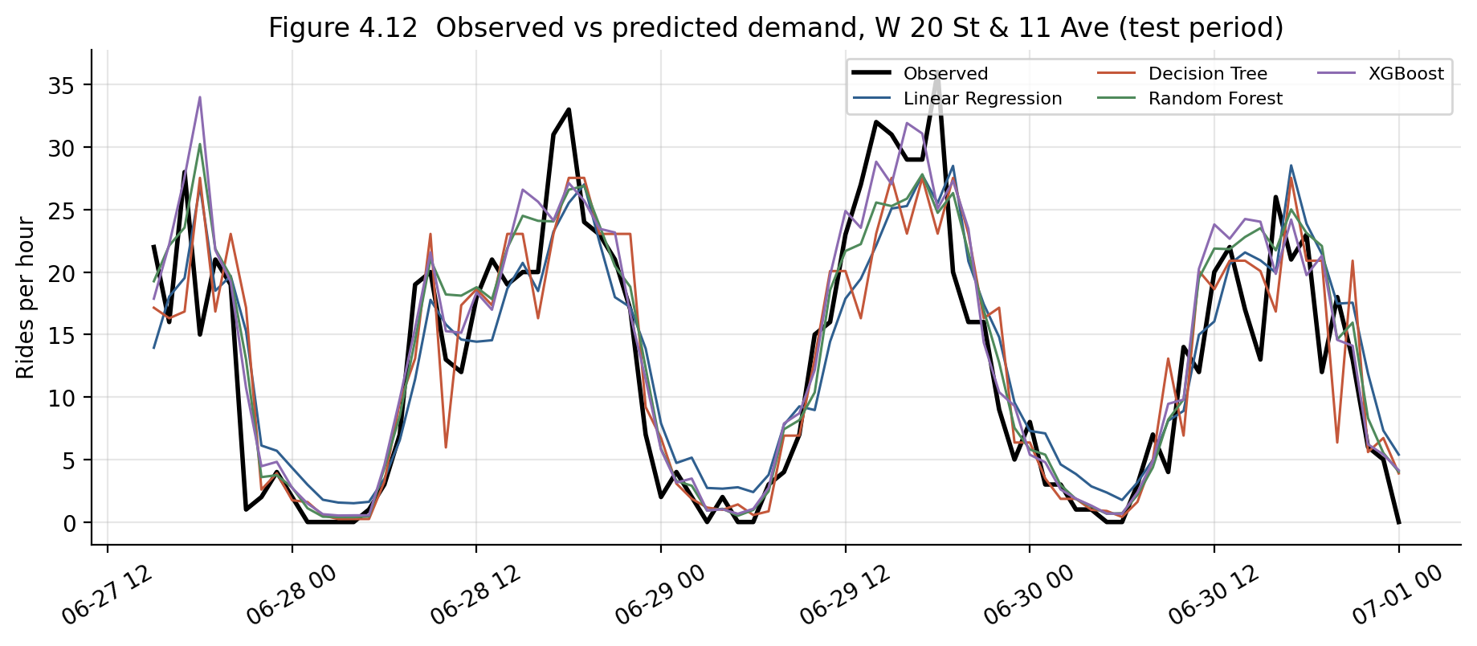
Figure 4.12
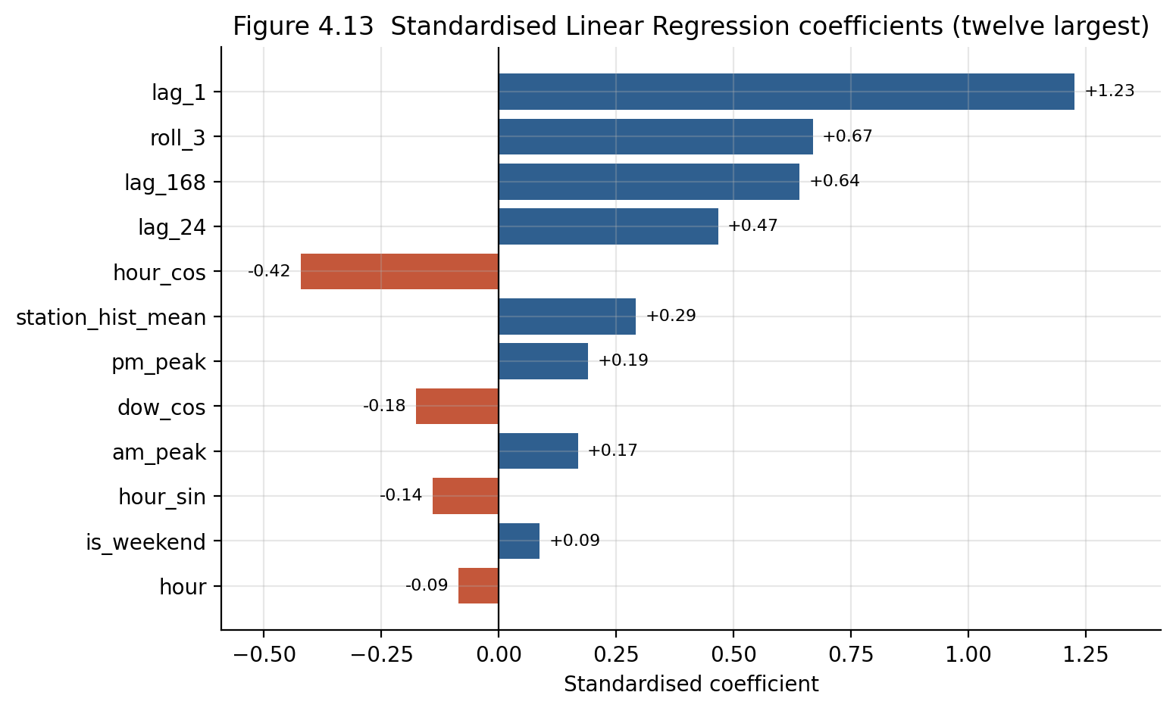
Figure 4.13
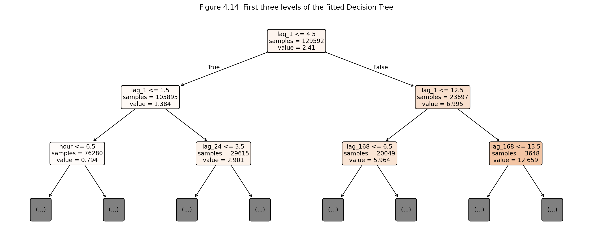
Figure 4.14
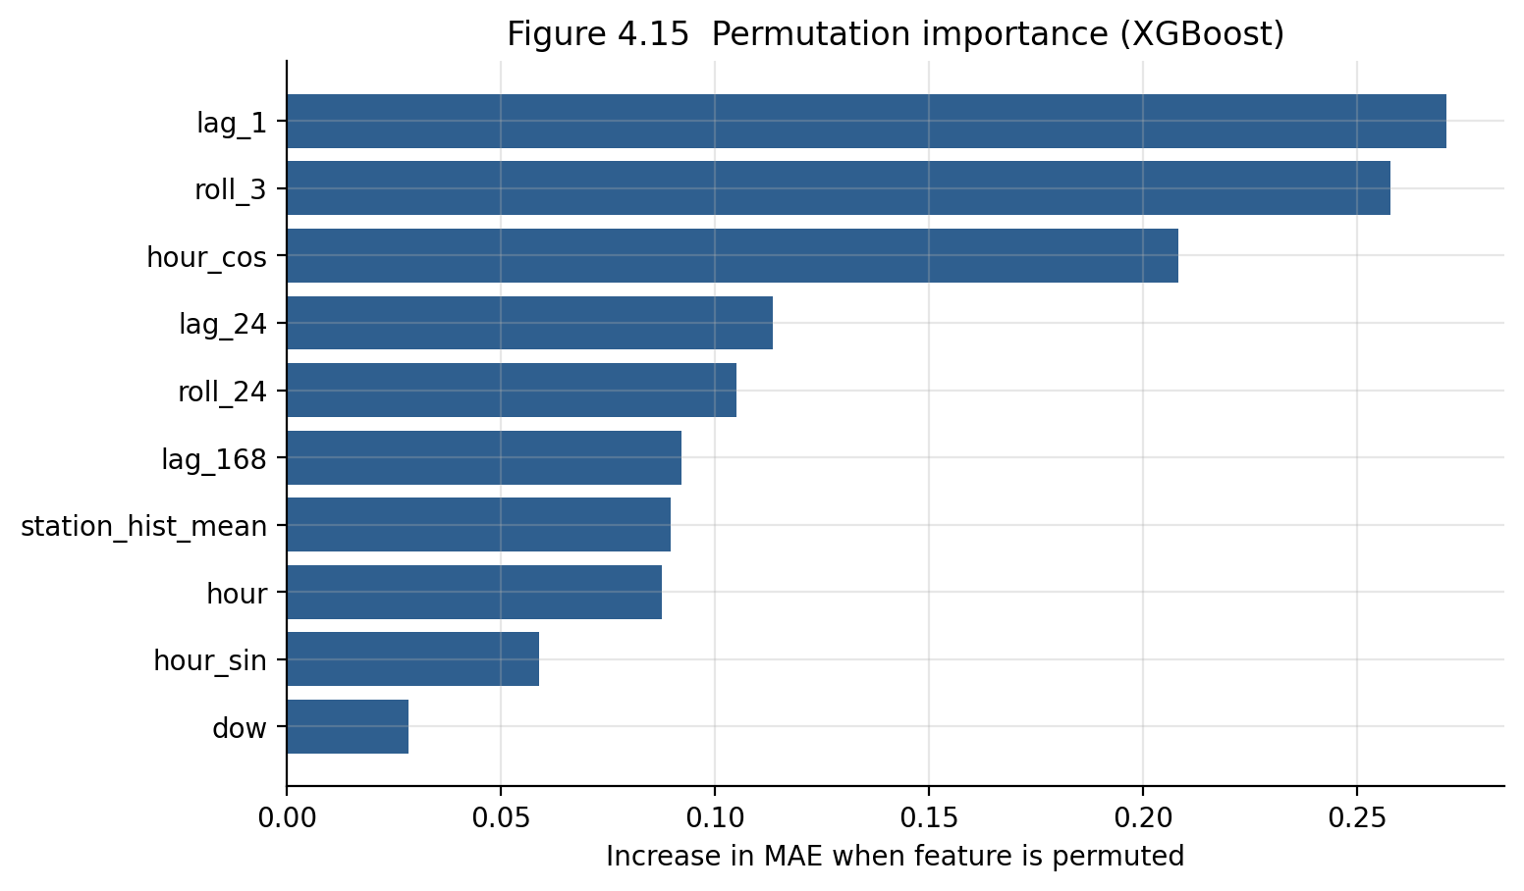
Figure 4.15
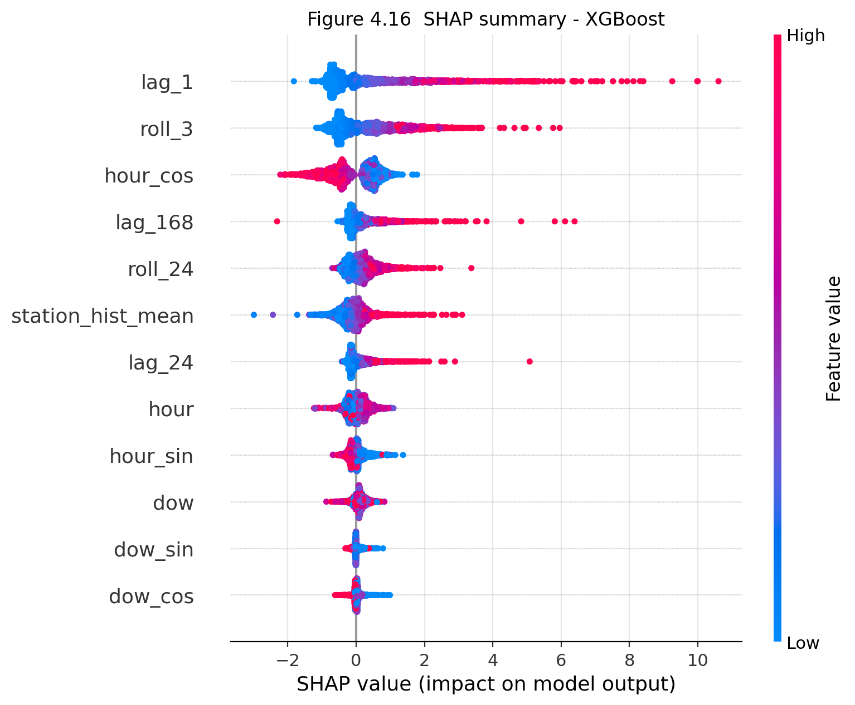
Figure 4.16
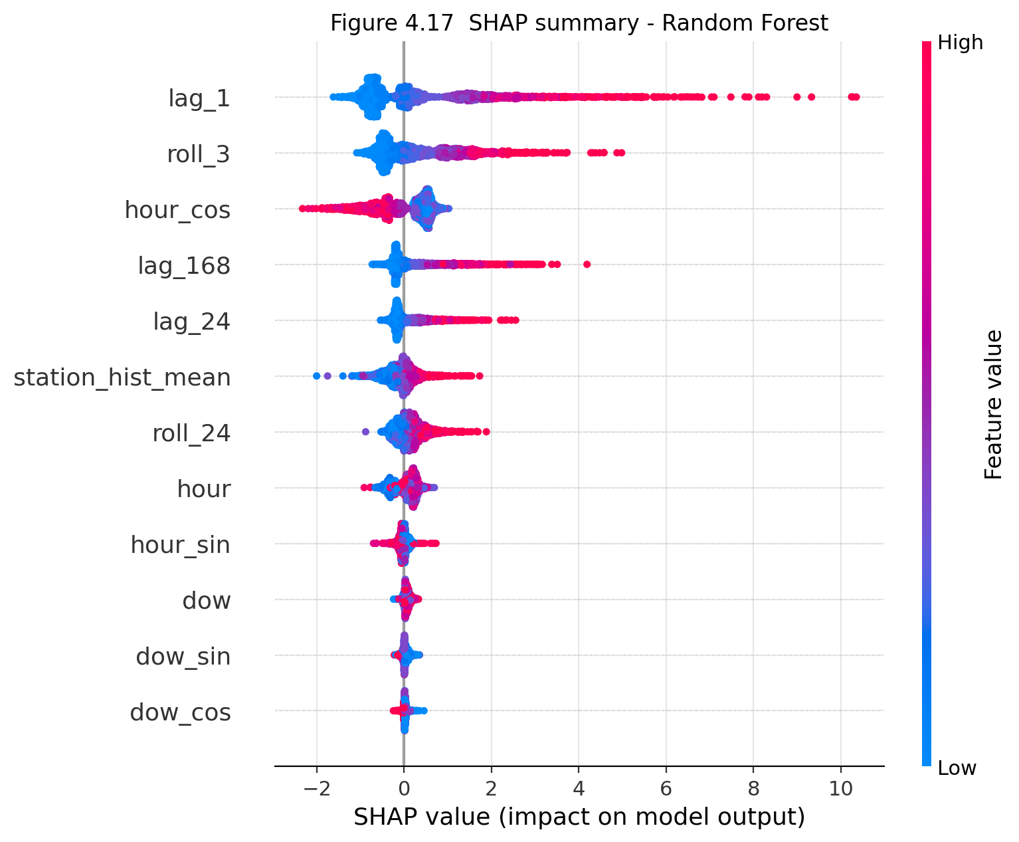
Figure 4.17
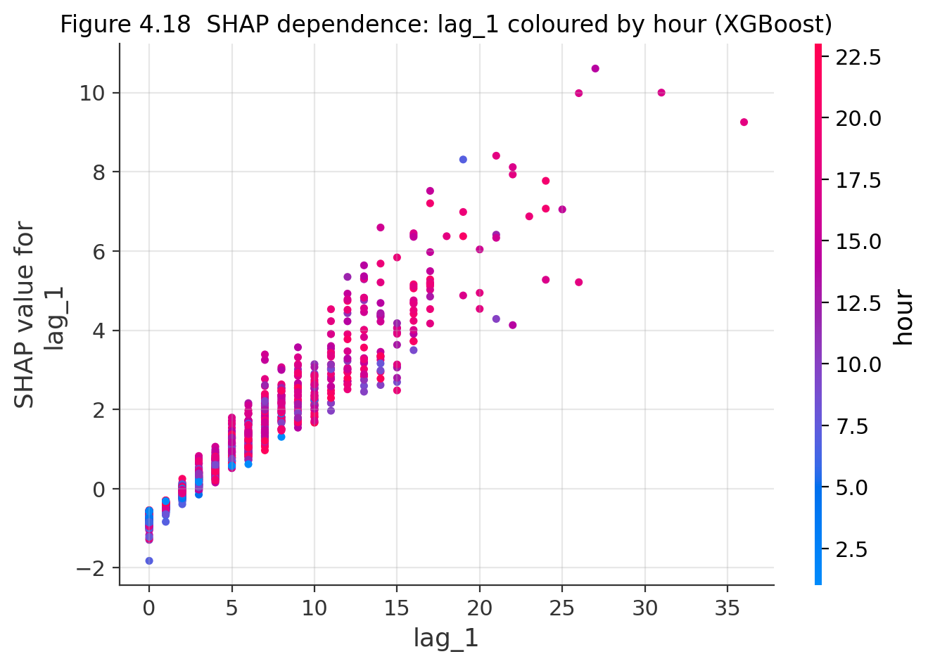
Figure 4.18
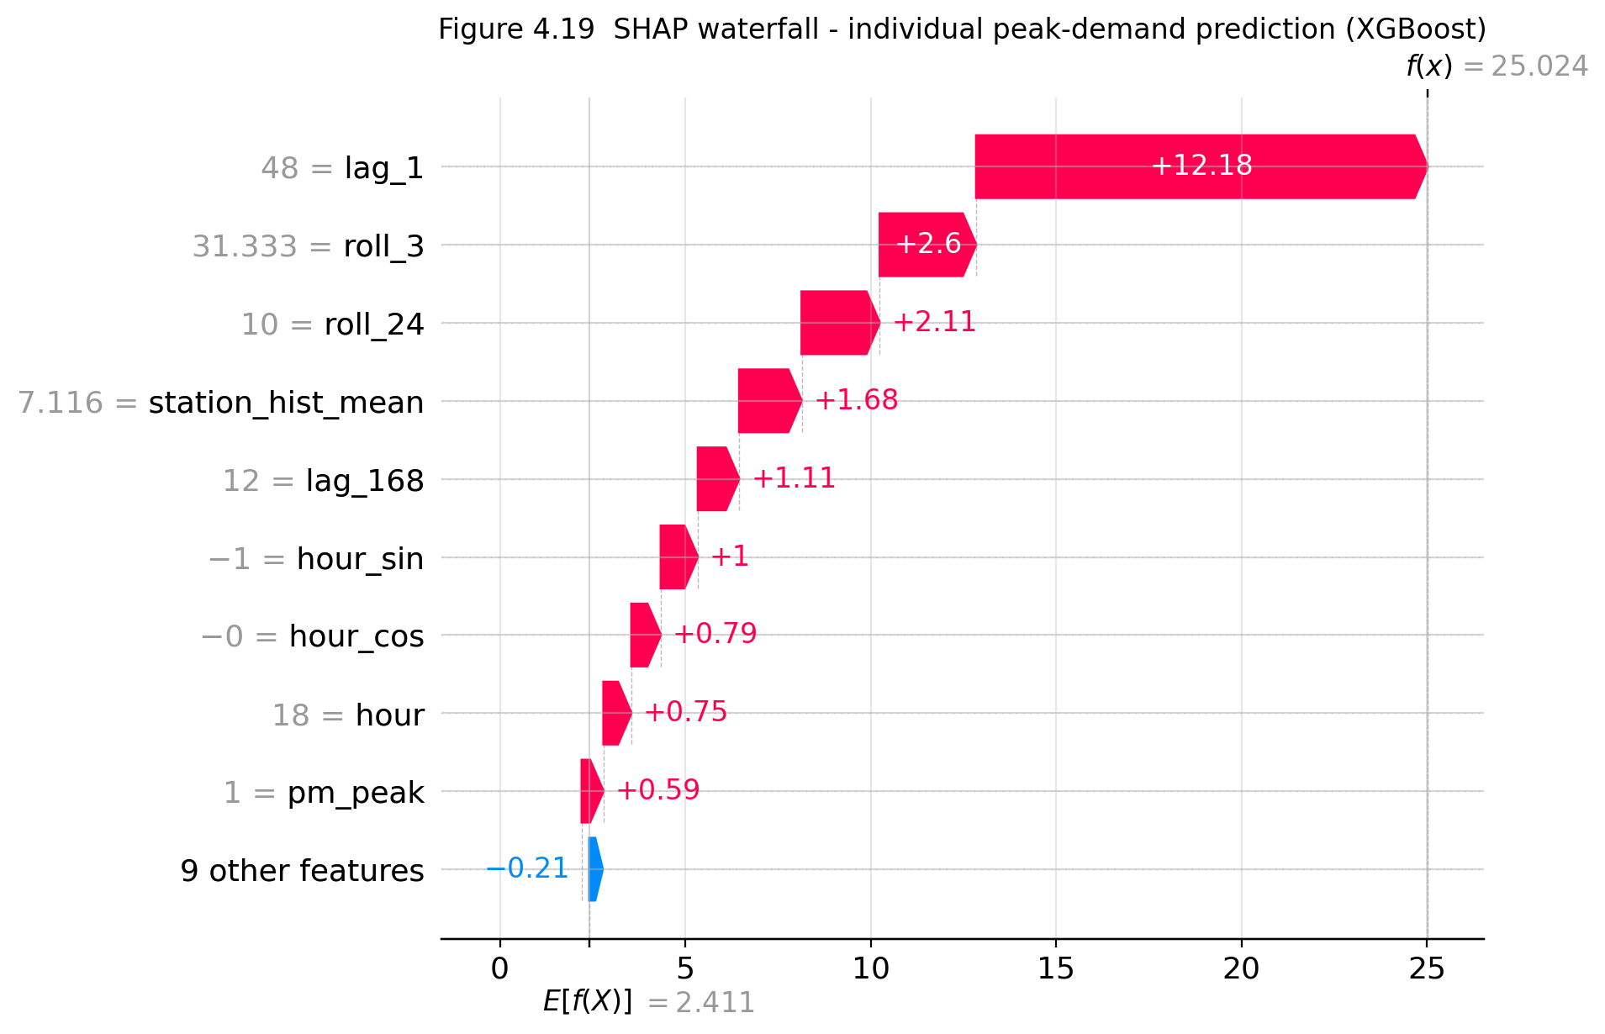
Figure 4.19

